**29th August Lambda**

1. Create two instances on EC2 server

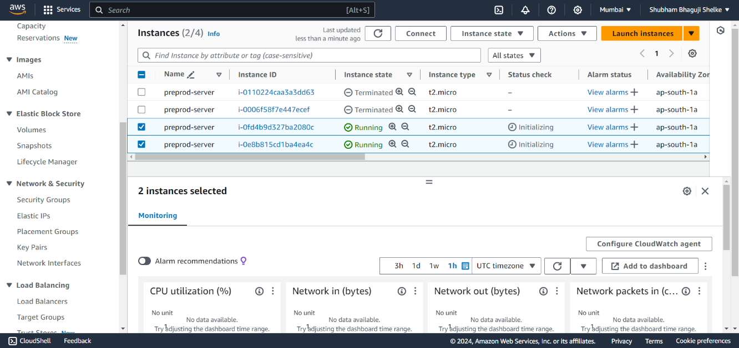

1. Add tags for the instance

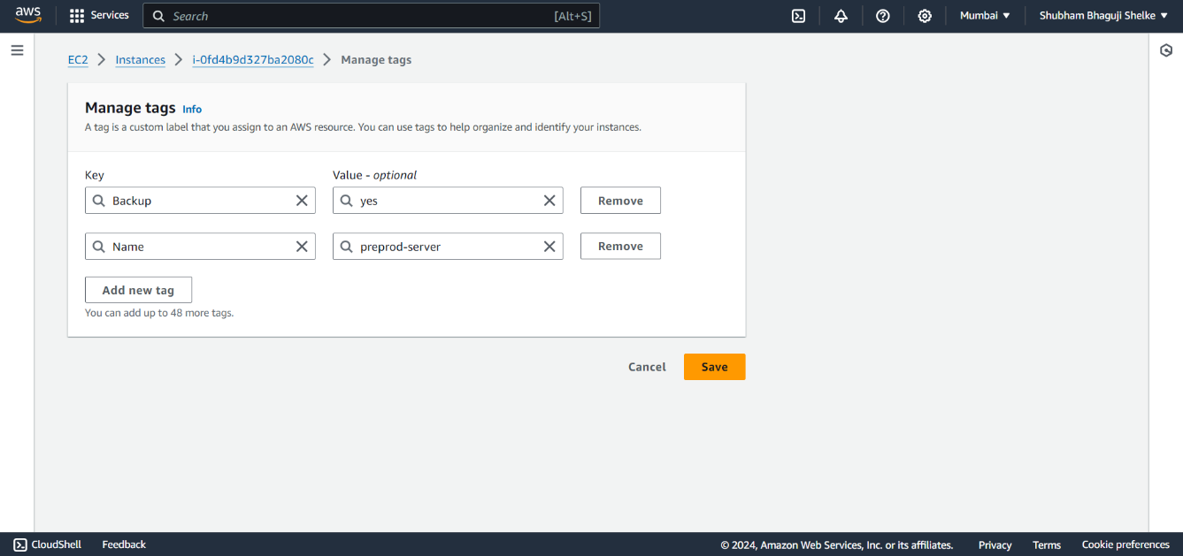

1. Create IAM role for Lambda service

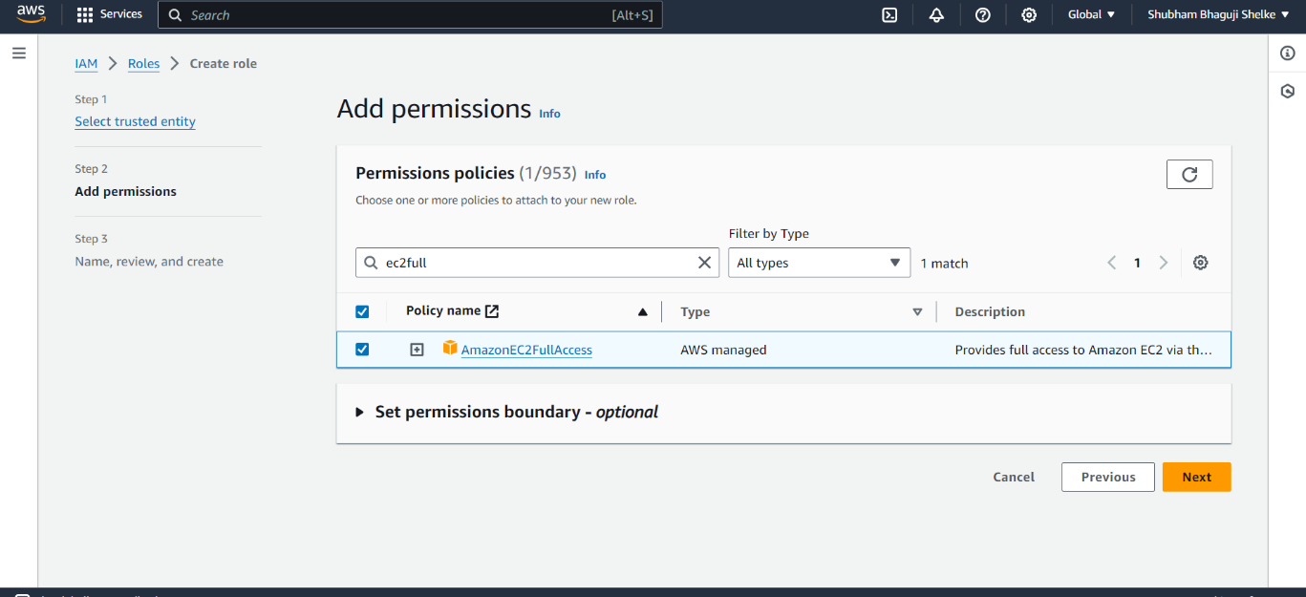

1. Create Lambda function

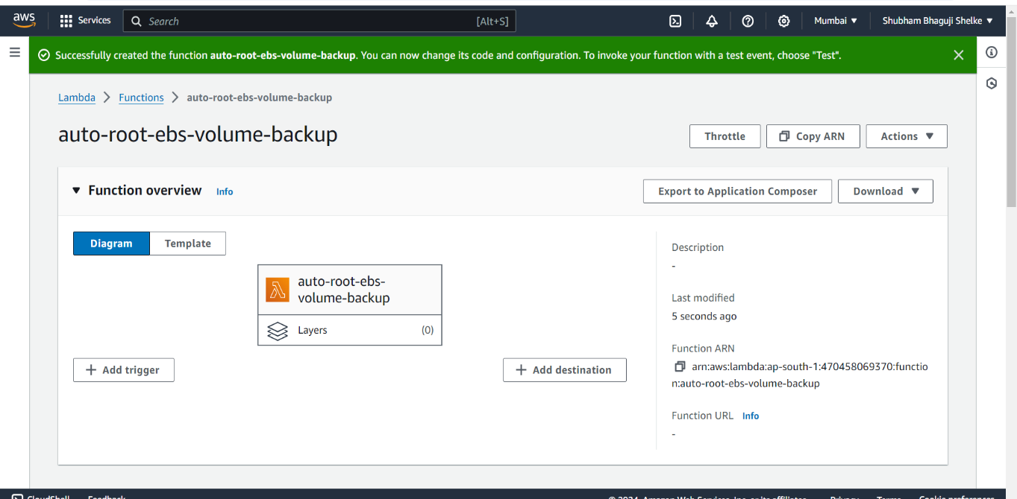

1. Deploy the python code

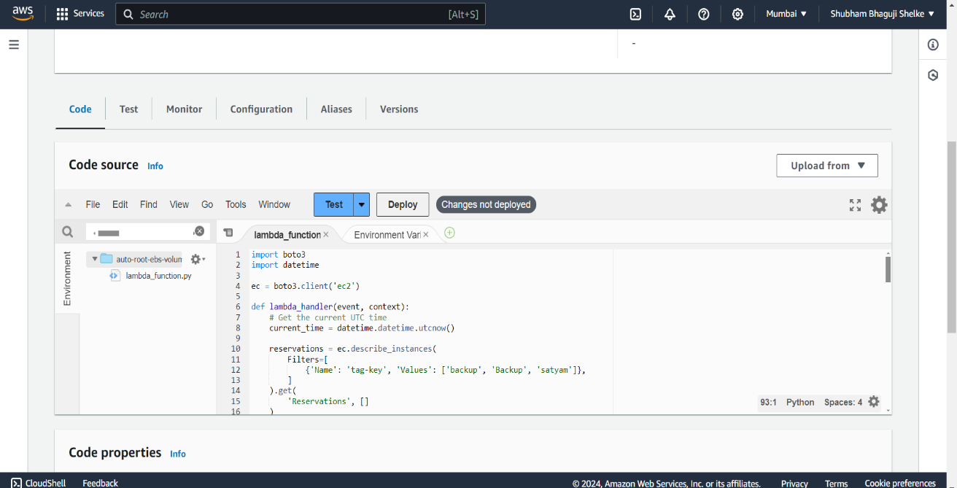

1. Run/Test the code with event name

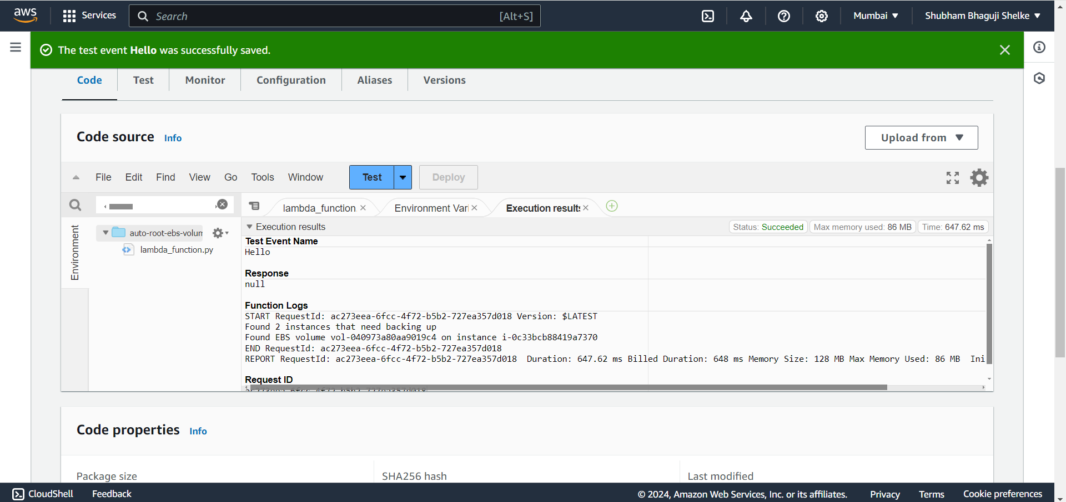

1. Hit/Run/Test the code 5 times to create 5 snapshots

